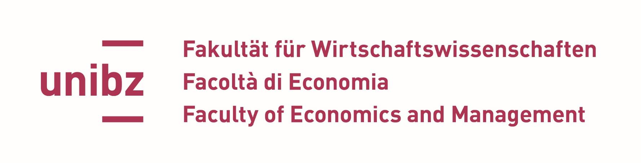

**2nd Accounting Summer Camp**

**2018 ERC Announcement and Call for Applications**

**Emerging Researchers Consortium in Accounting (July 3-4, 2018)**

**- Call for Applications -**

**@ Faculty of Economics | University of Bolzano (ITA)**

The Accounting Research Groups at the Free University of Bolzano and University of Padova are pleased to announce the second edition of the *Accounting* *Summer Camp.* The event will be held at the [University of Padova](http://www.unipd.it/en) the [Free University of Bolzano](https://www.google.it/maps/place/Libera+Universit%C3%A0+di+Bolzano/@46.4983517,11.3487724,17z/data=!3m1!4b1!4m5!3m4!1s0x47829e59df039ba5:0x8b7cb189094036de!8m2!3d46.498348!4d11.3509611) (Italy) on July 3-6, 2018. The *Accounting Summer Camp* aims at bringing together junior and more experienced researchers in empirical financial accounting and will host an *Emerging Researchers Consortium* (3-4 July) at the University of Bolzano, followed by the *Journal of Law, Finance, and Accounting Conference* (5-6 July) at the University of Padova.

Applications are now welcome to attend the *Emerging Researchers Consortium in Accounting*. This 2-day event will be led by:

Prof [Mark DeFond](https://www.marshall.usc.edu/personnel/mark-de-fond) University of Southern California

Prof [Per Olsson](https://www.esmt.org/olsson) EMST Berlin

Prof [Holger Daske](https://daske.bwl.uni-mannheim.de/en/chair/team/prof_dr_holger_daske/profile/) University of Mannheim

**Theme: Questions, Theories and Research Design in Accounting Studies: Searching for the Fit**

The Consortium aims at exposing emerging scholars to the most current and relevant research in accounting conducted by top-quality researchers, and letting participants interact and getting feedback on their research projects. The sessions will have the following format: (i) two key note speeches lead by the faculties in residence; (ii) a session in which emerging researchers and PhD students will present their work and receive feedback from the faculties in residence.

**Application Process:**

The consortium is open to all PhD students and emerging researchers (max three years from the award of the PhD) in Accounting. Applicants should submit a summary (max 2,000 words) of their research project (either a working paper or extracts of the PhD thesis) before **April 1, 2018.**

The submission should be structured (preferably) as follows:

(i) Motivation/Research Questions;

(ii) Theory and Hypotheses development (do not use too much space to review extant literature but motivate your hypotheses/propositions);

(iii) Methods and Research Design. We expect this to be the most substantial part of the submission. Discuss the data gathering process, introduce your key variables and illustrate the analyses you intend to carry out;

(iv) Expected Results & Contribution.

Attendance to the consortium attracts a fee of Euros 250 that will cover food and teaching material; participants will cover their own travel and accommodation costs.  We encourage all consortium attendees to stay on for the 2-day JLFA conference and dinner on July 5and 6 in Padova.

Places for are limited and anyone wishing to attend should register as soon as possible.

**Application & Registration Info**

Date of ERC July 3-4, 2018

Venue Free University of Bolzano, Bolzano (ITA)

Deadline Submission of Applications April 1, 2018

Notification of Acceptance April 27, 2018

Registration DeadlineMay 28, 2018

**Info & Application**

Should you have any enquiry, or wish to submit your application, please email @:

Amedeo Pugliese [Amedeo.pugliese@unipd.it](mailto:Amedeo.pugliese@unipd.it)

Massimiliano Bonacchi [massimiliano.bonacchi@unibz.it](mailto:massimiliano.bonacchi@unibz.it)