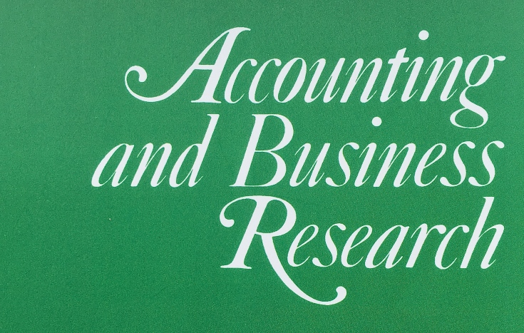
Call for Papers and Participants
Accounting and Business Research and China Journal of Accounting Research
Joint Conference on ‘Capital Markets Research in Accounting: Five Decades and Beyond’
16th – 17th November, 2019
Guangzhou, China

Conference Paper Submission Deadline:
31st August, 2019

Keynote Speakers:
Professor Ilia Dichev is the Goizueta Foundation Chair in Financial Reporting at Goizueta Business School, Emory University. His research expertise includes market efficiency, capital markets, corporate financial reporting, and earnings management. He has received some of the highest research awards in Accounting, including the Notable Contributions to Accounting Literature Award and Distinguished Contributions to the Accounting Literature Award.

Professor Katherine Schipper is the Thomas F. Keller Professor of Business Administration at Fuqua School of Business, Duke University. She was a Board member of the FASB, and is a frequent speaker on matters related to international accounting convergence, financial reporting standard setting, and financial reporting quality. She has been named the AAA’s Outstanding Educator and has been elected to the Accounting Hall of Fame.

Conference Venue:
Business School, Sun Yat-sen University, Guangzhou, China

Conference Working Language:
Paper, presentation, and discussion: English

Rationale and Scope:
This conference is organized jointly by Accounting and Business Research and China Journal of Accounting Research to celebrate five decades of capital markets accounting research. Over the past half century, this literature has evolved from the original returns-earnings relationship into an extensive array of research topics that advance our knowledge of the demand, supply, determinants, and consequences of accounting information. Beyond accounting, this literature has also contributed valuable insights to other academic disciplines including economics, finance, and management. Today, the crucial role of accounting information in capital markets continues to reverberate in the aftermath of the financial crisis of 2007-08 as businesses are confronted with increasing challenges from technological innovations and political uncertainty. In this conference, we bring together experts in the field to discuss the past, present, and future development of this important literature. Submissions of papers from any areas of capital markets research in accounting are welcome. Potential topics of papers include, but are not limited to:
- The intended and unintended economic consequences of changes in disclosure regulations or accounting standards on capital markets.
- The effect of the institutional environment and enforcement on financial reporting - either within a single jurisdiction (for example, China or other emerging economies) or comparison across countries, using international samples.
- The impact of non-financial information, such as ESG and business strategy disclosures, on capital market participants.
- The competing and complementary roles of alternative information sources, such as financial statement narratives, the business media and social media.
- The influence of alternative types of financial information intermediaries such as credit analysts, bond analysts, and buy side analysts.
- The role of different types of investors, such as short sellers, foreign investors, and institutional investors in shaping financial reporting processes.
- The differential impact or spill-over effects of accounting information across alternative types of securities markets.

Paper Submission Process:
The submission deadline for the Conference is the 31st August, 2019. Submission to the Conference should be emailed to: cjar@mail.sysu.edu.cn.

Please specify “Submission to ABR–CJAR Joint Conference” as the subject heading of the submission email. Authors should submit their papers in PDF format, with the title page of the manuscript indicating the name, affiliation, and contact information of the authors. An abstract of up to 150 words and a list of four to six keywords should follow the title page. All papers must be written in English, and non-native English speakers are advised to have their papers checked by a professional English language copyediting service. Authors of papers accepted for presentation at the Conference will be notified by the 1st October, 2019.

The aim of the Conference is to aid the development of papers, and afterwards the authors of the papers presented can choose to submit their revised manuscript that addresses the feedback of the Conference to the normal issue of either journal for further consideration following the standard review process.

Timeline:
Conference submission deadline | 31st August, 2019
Notification of acceptance to the Conference | 1st October, 2019
Conference dates | 16th–17th November, 2019

Participant Registration Process:
Participants are welcome to attend the conference even if they are not presenting papers, but are required to register by emailing their name, title, and affiliation to the following email address: cjar@mail.sysu.edu.cn. Please specify “Registration to ABR–CJAR Joint Conference” as the subject heading of the registration email. The registration is free, but will be on a first come first served basis due to the limited number of places, and participants will be notified in due course whether the registration is successful. The conference does not cover the travel and accommodation expenses of participants.

About the Journals:
Accounting and Business Research publishes original academic papers that contribute to the development and understanding of the role of accounting in business. The journal was founded in 1970 by the Institute of Chartered Accountants in England and Wales (ICAEW). It is included in the Social Science Citation Index (SSCI), classified in the Association of Business School (ABS) Journal Guide as Grade 3, and graded “A” in the Australian Business Dean Council’s (ABDC) Journal Quality List. According to the Journal Citation Report (2017) of Thomson Reuters, the journal’s 2- and 5-year impact factors are 1.271 and 2.023 respectively. Some of the most widely read articles and their contributors are available at:
http://www.tandfonline.com/action/showMostReadArticles?journalCode=rabr20

China Journal of Accounting Research publishes empirical and theoretical research papers that investigate issues about accounting, corporate finance, auditing, and corporate governance. The journal was established in 2008 by the Sun Yat-Sen University in Guangzhou, China and the City University of Hong Kong. It encourages studies of the Greater China region, as well as other emerging and developed markets. The journal has a CiteScore of 1.53 in 2018. It is classified in the Association of Business School (ABS) Journal Guide as Grade 2, and is included in the Emerging Sources Citation Index (ESCI). Some of the most cited articles and their contributors are available at:
https://www.journals.elsevier.com/china-journal-of-accounting-research/most-cited-articles

