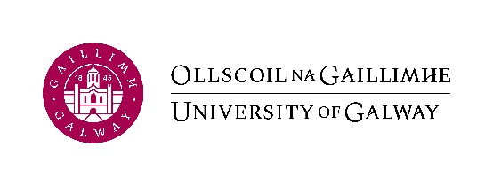

The 35th Irish Accounting & Finance Association (IAFA) Annual Conference and Doctoral Colloquium will be hosted by University of Galway from Wednesday 7th – Friday 9th June 2023.
- Wednesday 7th June - Doctoral Colloquium
- Thursday 8th June (full day) & Friday 9th June (half day) – Annual Conference

Guest Speakers:
- Professor Lee Parker – Distinguished Professor in Accounting in the School of Accounting at RMIT University, Melbourne, Australia and Visiting Research Professor of Accounting at the University of Glasgow
- Dr. Andrea Mennicken – Associate Professor of Accounting and Co-Director of Centre for Analysis of Risk and Regulation, London School of Economics
- Professor Lukas Goretzki – Professor of Management Accounting & Control, Stockholm School of Economics

A call for papers will be released in January 2023 with an expected submission deadline of late March.
For more information, please see www.iafa.ie
For any queries, please contact nolanj@universityofgalway.ie

