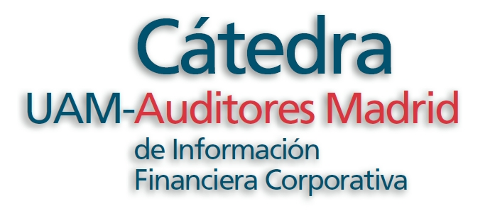 | XVIII International Accounting Research Symposium  Current Trends in  Accounting Research | 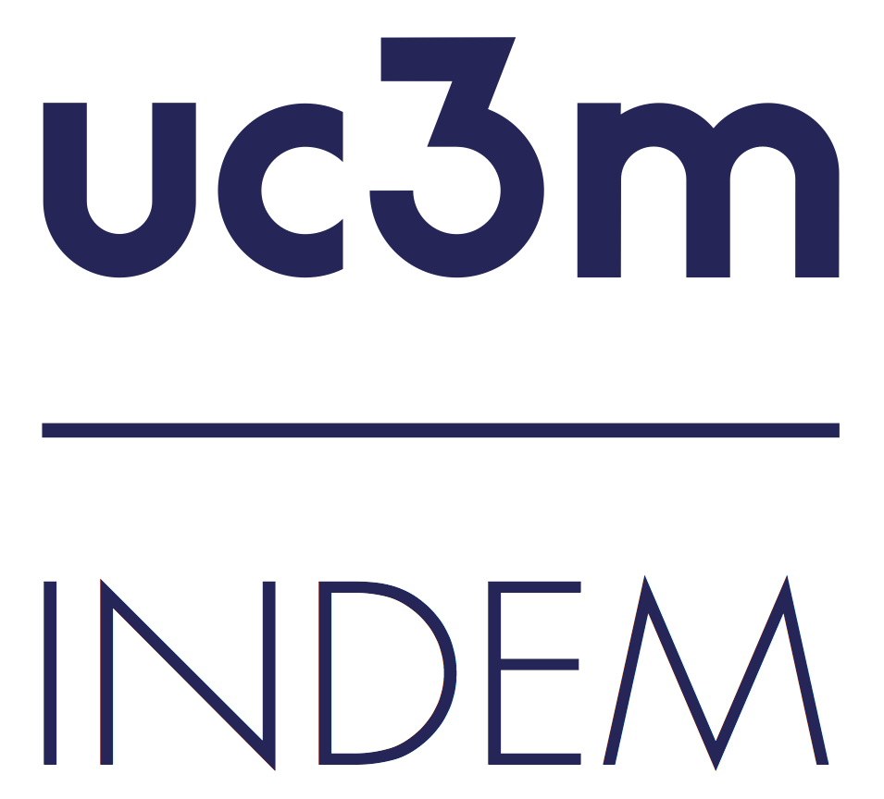

Director: Prof. Leandro Cañibano
Coordinator: Prof. Beatriz García Osma

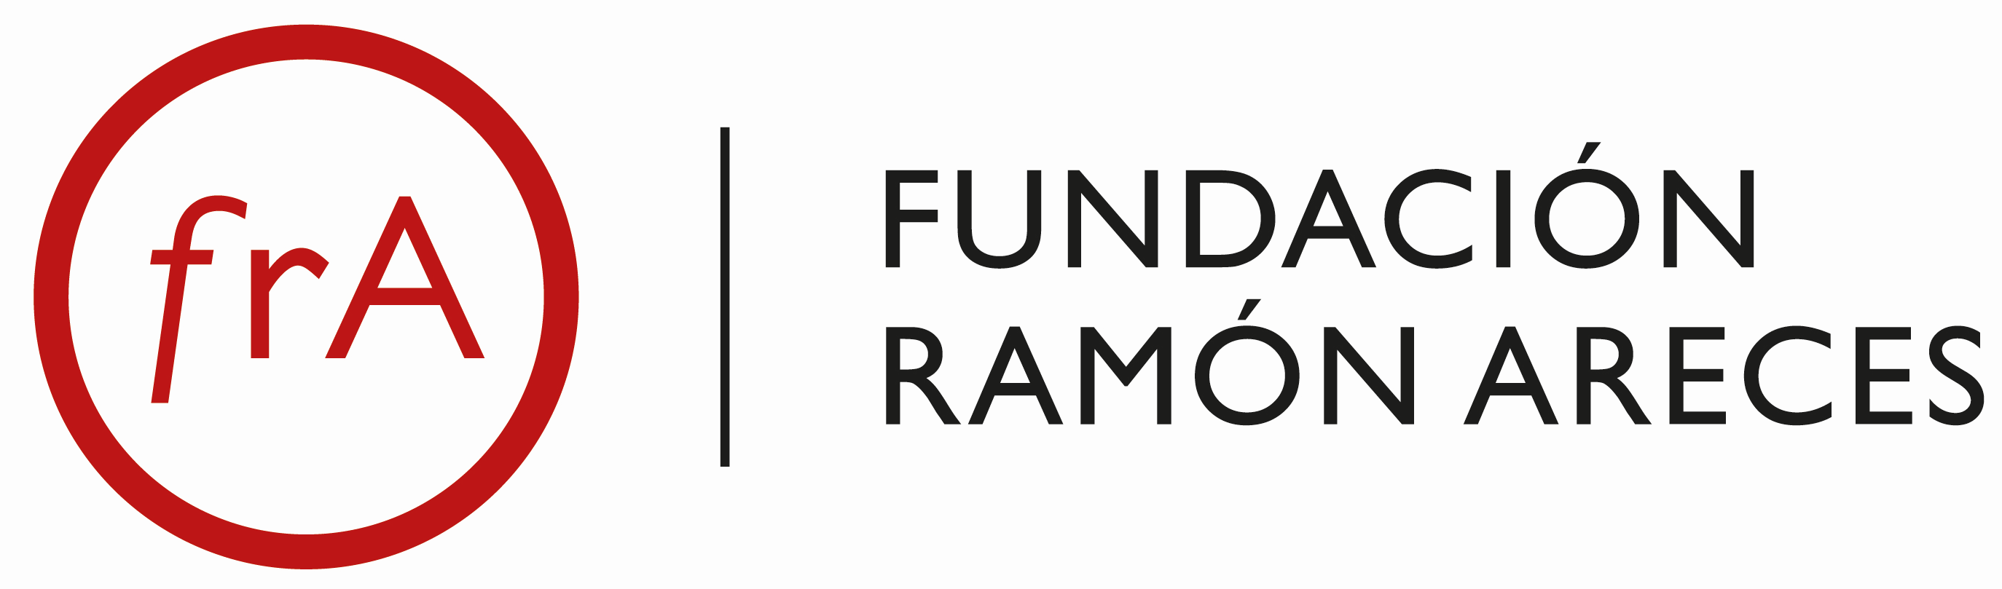

July 10-12, 2024

Objective and Introduction

The Symposium is addressed to PhD students, early-stage faculty and researchers in Accounting and Finance. It represents a unique opportunity to attend lectures by expert faculty, and also, to interact with colleagues and receive feedback both on developed (papers) and developing projects (early-stage ideas).

Faculty

The invited faculty are:

- Prof. Hans B. Christensen (University of Chicago).
- Prof. Aloke Ghosh (UNC Charlotte).
- Prof. Matthias Mahlendorf (Frankfurt School of Finance).

In addition, we will also host an editor’s and career’s panel, that will be led by prof. Beatriz García Osma and Prof. Juan Manuel García Lara (both from Universidad Carlos III de Madrid-UC3M, host). Finally, we will host presentations by participants, whereby preference for presentation will be given to proposals closely linked with the topics of the presenters as well as to early stage faculty and PhD students.

Presentations by participants

Participants are invited to present their papers or ideas, particularly, on topics linked to the areas discussed by the Faculty. All participants are thus encouraged to submit their own research for presentation at the symposium. Papers linked to the areas discussed by the speakers and by early-stage researchers will be given preference. There will be, after each presentation, sessions dedicated to participants’ presentations, chaired by the professor leading the session. These sessions will be attended by diverse Faculty from the Symposium as well as from both of the host institutions, Universidad Autónoma de Madrid and UC3M.

Registration and Fees

Registration is free of charge and open until June 25, 2024.

Programme

The expected programme is as follows.

Sessions | Wednesday, 10th July 2024
9:45-10:00 | Welcome address
10:00-13:00 | Current topics in financial accounting research |  | Al Ghosh  UNC Charlotte
10:00-13:00 | Participant presentations  Developing projects
14:30-17:30 | Panel on Career considerations, Providing and Learning from Feedback |  | Beatriz García Osma  Juan M. García Lara  Universidad Carlos III de Madrid  Al Ghosh  UNC Charlotte
14:30-17:30 | Participant presentations  Developed projects
Sessions | Thursday, 11th July 2024
10:00-13:00 | New data sources for management accounting research I |  | Matthias Mahlendorf  Frankfurt School of Finance
10:00-13:00 | Participant presentations  Developing projects
14:30-17:30 | New data sources for management accounting research II |  | Matthias Mahlendorf  Frankfurt School of Finance
14:30-17:30 | Participant presentations  Developed projects
Sessions | Friday, 12th July 2024
10:00-13:00 | Corporate Social Responsibility and Policy Assessment in the Global South I |  | Hans B. Christensen  University of Chicago
10:00-13:00 | Participant presentations  Developing projects
14:30-17:30 | Corporate Social Responsibility and Policy Assessment in the Global South II |  | Hans B. Christensen  University of Chicago
14:30-17:30 | Participant presentations  Developed projects

Practical details

Contact person: Estela Martínez (conference_business@uc3m.es)
Deadline to register: June 25, 2024
Website: https://indem.uc3m.es/en/workshop/d/37/xvi-international-accounting-research-symposium
Fundación Ramón Areces: http://www.fundacionareces.es/fundacionareces/

Speakers Profiles

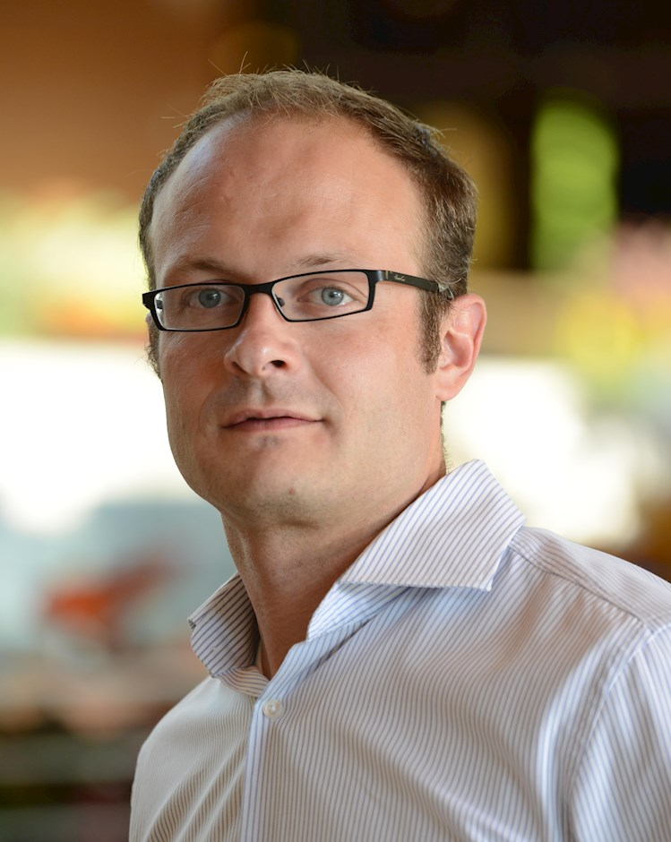 | Prof. Hans B. Christensen  University of Chicago  hans.christensen@chicagobooth.edu  Hans Christensen's current research primarily focuses on the effect on society of regulation aimed at incentivizing firms to act socially responsible. This includes the effect of transparency regulation on healthcare prices and labor safety, as well as, foreign corruption regulation on economic development. His papers have been published in the Journal of Accounting Economics, the Journal of Accounting Research, Review of Accounting Studies, and Review of Financial Studies.
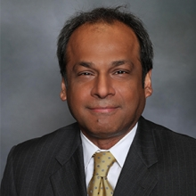 | Prof. Aloke Ghosh  UNC Charlotte  Al.Ghosh@uncc.edu  Al Ghosh was previously at Baruch College and has been awarded the Fulbright Distinguished Chair by the U.S. State Department and Fulbright Finland. He has also served as an Academic Fellow at the U.S. Securities and Exchange Commission and as a visiting research scholar at Aalto University (Finland), AUP (Paris, France), Bocconi University (Italy), or Columbia University. He has published in leading outlets like The Accounting Review, The Journal of Finance, or the Journal of Accounting and Economics.
 | Prof. Matthias Mahlendorf  Frankfurt School of Finance  m.mahlendorf@fs.de  Matthias D. Mahlendorf is interested in the areas of performance measurement – especially with respect to managing sustainability performance – as well as the digital transformation of management control. He regularly publishes in academic journals as well as in journals aimed at executives in corporate practice. He was a visiting scholar at Harvard Business School, a visiting professor at the University of Chicago (Booth School of Business) as well as an adjunct professor at INSEAD. He has published in journals such as Journal of Accounting Research, Management Science, and The Accounting Review.

