AI and FinTech Research
A One-week Long Intensive Course
Summer 2025 (25.-29.8.2025)
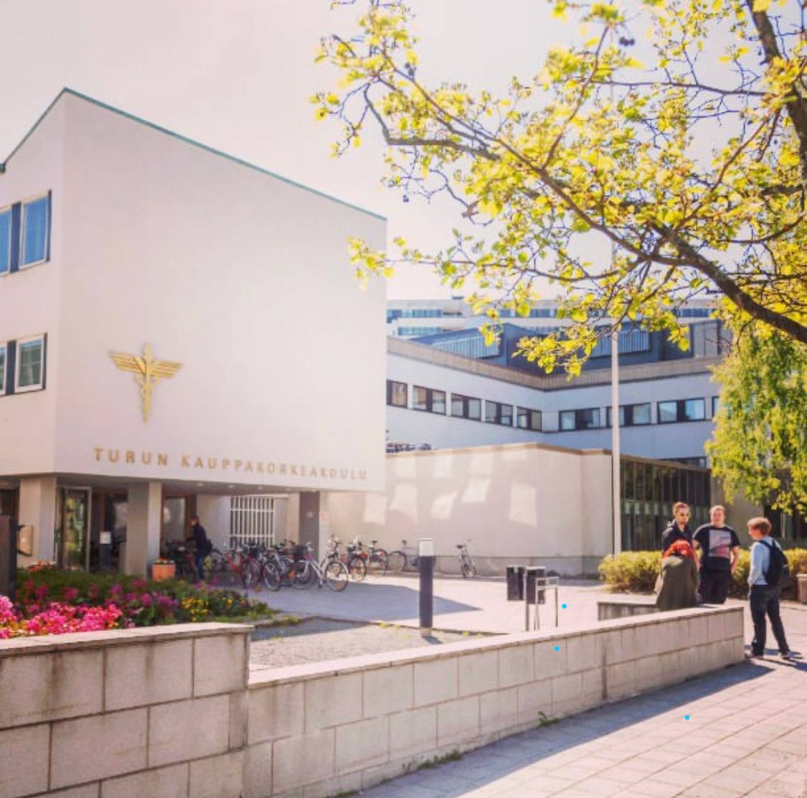

Topic and Targeted Audience
The general purpose of this course is to guide adjoining or related areas of research in accounting, especially the role of AI and Fintech in this field.
This course is open to everybody interested in research on AI and Fintech in accounting and finance. It has been designed for Ph.D. students, beneficial for business, economics, and related social sciences, to get familiar with current research in this field and take their first steps toward doing independent research on this topic. In contrast to other courses, we will cover fewer papers but more thoroughly than typical in such seminars. After completing the course, course participants will understand the papers’ main findings and have reviewed them critically. Also, they can develop research projects that add to this fascinating and relevant field.

Artificial Intelligence and FinTech Research
Practical Perspectives
A set of instructive videos outlines critical concepts for the practical perspectives. The objective of the lectures is to allow non-computer-science scholars to adopt machine learning to finance and accounting research smoothly.
Video 2: Textual analytic tools in Accounting and Finance
Besides, during the course, unstructured qualitative data sources will be covered:
- Firm disclosure
Textual data
- Mandatory SEC filings, e.g, 10-k, 8-K, proxy statement, IPO Form S-1
- Voluntary SEC filings, e.g., conference call transcript
- Mandatory Mutual fund SEC filings, e.g., Form N-CSR
Image data
- Product/production images
- Regulatory disclosure (comment letters)
- Social media data
- Analyst reports

Note: Successful completion of the course will be rewarded with 6 ECTS. No grades are given in the assessment (passed/failed).
Structure
The objective is to cover both classical accounting and finance theories and emerging technologies and how firm information (disclosure and reporting) helps investors’ trading decisions and managers’ corporate decisions. We also discuss emerging topics such as using textual analysis and machine learning to analyze firm information, e.g., SEC filings, corporate presentations, conference calls, and social media. To know about the course, please see the below video:
Video 1: Outlook of Fintech and AI research
Theoretical Perspectives
- Machine learning literature review and big data examples in finance and accounting
- Unsupervised machine learning for clustering and dimension
- Transfer Learning and Google BERT
- Textual Analysis and Natural Language Processing (NLP)
- Image representation, processing, segmentation, and feature extraction
- Machine learning examples using financial image, voice and video data, and academic research etc.

)

Instructor
Dr. Cao is an associate professor of AI, FinTech, and sustainability (with tenure) in the Robert H. Smith School of Business at the University of Maryland. His research has been featured in the Financial Times, CNBC, Bloomberg, The Guardian, and Quartz. To date, Dr. Cao has given over 100 invited research talks at major research universities. Dr. Cao also serves as a guest associate editor at Management Science. In 2020 and 2022, Dr. Cao co-chaired conferences with the Review of Financial Studies (dual submission) on Fintech and Machine Learning (https://sites.google.com/view/seancao/home).
Dr. Cao is deeply committed to helping business communities through his research. He has been honored with the award by the Deloitte Initiative for AI and Learning (DIAL), leading to develop AI solutions for social inclusion and climate change.
Course coordinator
Hannu Schadewitz is Professor of Accounting. His primary areas of research interest include discretionary corporate reporting, international accounting, governance, and accountability.
Course Assistant
Doctoral Researcher Javad Rajabalizadeh.
Housing
Each student is responsible for travel expenses, accommodation, and meals.
Admission
The application deadline is 9.6.2025, and students will be notified of acceptance by 18.6.2025. Applicants should send CV and application form to Hannu Schadewitz (hannu.schadewitz@utu.fi) in one pdf document with the file name
“firstname_lastname_aifintech_application”.
Course Application Form
The application form should include the following information, respectively:
Name, Contact address, Email, University, Department, Discipline/Major, Official year of acceptance in doctoral program, Research area/Subject of thesis, Phase of doctoral studies, Motives for participating in the course.
Important Dates
Application deadline: 9.6.2025
Notification of Acceptance: 18.6.2025
Kick Off Session: 15.8.2025
Time: Summer 2025, 25.-29.8.2025
Prerequisites and Admittance

No prerequisites are required for this course; watching instructive videos is sufficient. A maximum of 25 students will be selected based on KATAJA’s guidelines. The course is free of charge.
University of Turku | School of Economics  FI-20014 University of Turku, Finland  Telephone +358 29 450 5000 |  | utu.fi/tse-en


