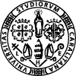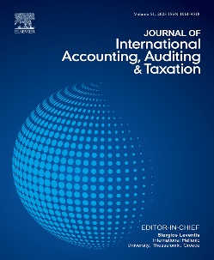

First Joint International conference
the Journal of International Accounting, Auditing & Taxation
and
The Journal of Management and Governance
University of Cagliari (Sardinia, Italy)
Friday 26th and Saturday 27th September 2025
Call for Papers

We are pleased to announce the inaugural joint international conference organized by the Journal of International Accounting, Auditing & Taxation (Q1, Impact Factor 3.3, Citescore 5.3) and the Journal of Management and Governance (Q1, Impact Factor 3.3, Citescore 9.4), hosted at the University of Cagliari, Sardinia, Italy.

The conference aims to foster the development of ideas and working manuscripts for future submissions to either of the two esteemed journals. Consistent with the missions of both journals, submissions on all relevant topics at all development levels and employing various empirical methods are invited to the conference. Constructive feedback will be provided by senior editors and other internationally renowned scholars.

The conference will comprise developmental paper sessions and a doctoral stream, addressing key areas of accounting, auditing, taxation, management, and governance, and is potentially of interest to experienced academics as well as early research scholars (including PhD students) who are interested in developing their works.

Working papers (or extended abstracts) are invited on the following topics of accounting, auditing, taxation, management, and governance, and may take empirical, theoretical, and conceptual approaches. Topics of interest include but are not limited to the following:
- The purpose of corporations
- Financial reporting, auditing, and taxation in the international setting, including individual countries
- The relationship between management and corporate governance
- Sustainability, integrated and environmental reporting
- Corporate governance and sustainability
- The role of corporate reporting and corporate governance in capital markets
- The role of the board of directors and its committees
- Performance measurement and incentives for executives and directors
Extended abstracts or full papers can be submitted by June 16, 2025, by emailing jmg@unica.it. For informal queries, you can email melisa@unica.it or s.leventis@ihu.edu.gr. For developmental paper sessions, please submit a full paper (up to approx. 12,000 words) or an extended abstract (up to 2,000 words). For the doctoral stream, please submit an abstract (maximum 500 words) or developmental paper (up to approx. 6,000 words).

Exceptionally good papers will be invited by the Editors for submission for a fast-track review in either the Journal of International Accounting, Auditing and Taxation or the Journal of Management and Governance.

Andrea Melis Stergios Leventis
Editor in Chief Editor in Chief
Journal of Management and Governance Journal of International Accounting, Auditing and Taxation
melisa@unica.it s.leventis@ihu.edu.gr

